

Trustee Recruitment Pack

Digital Trustee

Contents

Join us to create a world where bumblebees are thriving and valued by everyone 3
Digital Trustee Role Description 4
About Bumblebees 6
Governance 7
Organisational overview 7
Management Structure 7
What being a Trustee involves 8
Recruitment Timeline 10
How to Apply 10

Join us to create a world where bumblebees are thriving and valued by everyone
Thank you for your interest in the role of Digital Trustee. This pack outlines who we are and who we are seeking to join our leadership team. This is your chance to be part of an organisation that is working with passionate people to deliver a positive impact on the environment.
Trustees work together, and with the executive team, with a spirit of openness and trust. We recruit individuals skilled in their field to fulfil the Board’s governance role, who are also passionate about nature, species conservation and bumblebees!
We’re very proud of our inclusive culture at the Trust – we care as much about what you have the potential to do, as what you have already done. We therefore welcome applications from those who are new to trusteeship, as well as those with previous experience. We value different perspectives to give us a better representation at Board level of the diverse audiences we seek to inspire to take action for bumblebees.
The Bumblebee Conservation Trust is a science-led organisation established in 2006 because of serious concerns about the ‘plight of the bumblebee’. In the last 80 years, our bumblebee populations have crashed. Two species have become nationally extinct, and several others have declined dramatically.
We have a vision to create a world where bumblebees are thriving and valued by everyone. Bumblebees are in crisis, and we are leading the fight to secure their future. Guided by the latest science we carry out research, influence environmental policy and conserve and create bumblebee friendly habitats. We inspire people and organisations to take action for our precious bumblebees, working together to help them thrive.
Our current ten-year strategy launched in April 2024 sets out five main aims to focus our work:
- We are the UK’s trusted experts on bumblebee populations, ecology and conservation.
- People and organisations, including policy makers, are inspired to champion and take action for bumblebees.
- There is more, better-connected, high-quality habitat for bumblebees across our cities, towns and countryside.
- Our threatened bumblebees are on the road to recovery, and no other bumblebees become threatened.
- We are an impactful, inclusive, bold and sustainable organisation.
We currently employ ca.50 staff, in full and part time roles, with an annual turnover of ca. £2m. The work of the Trust is supported by over 7,000 members. You can read more about our strategy and work at www.bumblebeeconservation.org
If you feel you could contribute your skills and experience to the strategic leadership of the Trust, then we would very much like to hear from you.
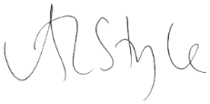
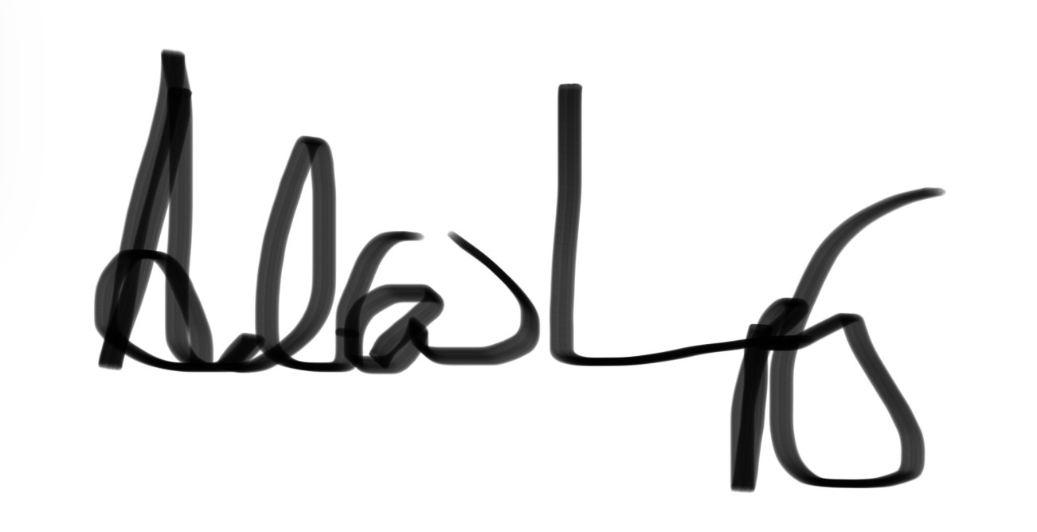

Angela Style Dr Andrew Impey
Chair of the Board of Trustees Chief Executive

Digital Trustee Role Description

Background: A background in any of the following areas: digital and IT strategy, software/web design (including UX/UI), network/ system management, cyber security.

Role Summary: The Digital Trustee will provide strategic oversight and expert insight into technology strategy, digital innovation (including AI) and cyber security. This role is key to ensuring technology and data are used securely, ethically, and efficiently to advance the Trust's mission. This role will provide strategic advice and oversight for the staff team, in identifying risks and opportunities relating to emerging technologies, and will support the board in governance in this area.

Main Responsibilities
- Provide thought leadership on the role of digital in the Trust’s strategy and help build and implement this vision.
- Highlight the opportunities and the risks of digital, translating these for other trustees, to enable the Board as a whole to engage in an informed way.
- Provide oversight and advice on cyber risks, data protection, and ethical AI use to protect the charity’s reputation and assets.
- Advise on the use of AI and digital technologies to build internal capability and efficiency, improve service design, enhance data-driven decision-making, and expand our impact.
- Champion the use of data in board discussions, and in driving the delivery of our strategy.
- Act as a "critical friend" to the Senior Leadership Team (SLT) and Digital & IT Manager on technical issues.
- Be an active champion of the organisation.
- Support the effective implementation of the strategy through governance of operational matters.
- Work to the Trust’s values and commitment to diversity, inclusion and equity.

Digital Knowledge and Experience
- A background in senior digital, technology, or information leadership, gained through executive roles, consultancy, or board level advisory work.
- A digital visionary, with a strong understanding of how organisations - particularly charities - can make effective, appropriate, and ethical use of digital technology to achieve their mission.
- A strategic understanding of digital services, including how systems, data, and infrastructure work together to support efficient, user centred services.
- An understanding of current and emerging digital opportunities and risks, and how these may affect organisational strategy, sustainability, and delivery.
- A working awareness of cyber security risks, including how threats are evolving and what good organisational oversight and assurance look like.
- An understanding of the opportunities, challenges, and ethical considerations presented by Artificial Intelligence, at a level appropriate for governance and strategic decision making.
- An understanding of good data protection practice, including how GDPR principles apply to digital systems, processes, and ways of working.
- An appreciation of the financial constraints that charities operate within, and how to achieve best value, sustainability, and impact from digital investment.
- The ability to interpret technical or specialist advice and translate it into clear, meaningful insights to support effective board discussions and decision making.

General Qualities
- Ability to work as part of a team and willingness to take collective responsibility for the governance of our charity.
- Ability to work at a strategic and visionary level whilst understanding the detail and complexities of delivery.
- Ability to analyse risks and opportunities and take a balanced approach to both.
- Extensive networks, and a willingness to draw on contacts as appropriate.
- An appreciation of the challenges facing small UK conservation charities.
- An appreciation of the UK charity sector, good governance, charity regulators’ requirements, relevant legislations and statutory requirements.

Commitment
- Board roles are not remunerated, though reasonable travel expenses will be paid.
- An initial three-year term, that may be extended for one further three-year period.
- Time commitment equates to around a day a month, with time required during office hours, for Board and Committee meetings (including prep), the AGM, strategy work and training. We work via a combination of remote working, videoconferencing and in person meetings.

Recruitment and selection for this role will be conducted on the basis of merit, against objective criteria that avoid discrimination. Our recruitment procedures are reviewed regularly to ensure that applicants are treated fairly on the basis of their relevant skills and abilities.

About Bumblebees
As a society we are increasingly dependent on pollinators. The proportion of global agricultural production that depends on pollinators has increased four-fold since 1961. Much of this dependence is linked to wild pollinators. Where data exist, we are seeing evidence of wild pollinator decline. Over 16 per cent of invertebrate pollinators are threatened with global extinction, 9 per cent of wild bee and butterfly species face local extinction and available National Red Lists show up to 50 per cent of bee species assessed are nationally threatened.
Pollinators provide a crucial service to nature and humans. Pollination directly affects the yield and/or quality of 75 per cent of globally important crops. The annual contribution of pollinators to the global economy is estimated at US$ 235–577 billion (Potts et al 2016).
It is well-known that bumblebees are extremely important pollinators, and they have a key role in producing much of the food that we eat. Through the pollination of many commercial crops such as tomatoes, peas, apples and strawberries, insects are estimated to contribute over £600 million per annum to the UK economy (2015), and in doing so prop up the £108 billion per-year food and drink industry in Britain. Across the EU, insect pollinators are estimated to contribute €14.2 billion annually to the EU economy (2012). If bumblebee and other insect pollinator declines continue, the extremely high cost of pollinating these plants by other means could significantly increase the cost of fruit and vegetables (hand-pollinating British crops has been estimated to cost £1.8 billion annually).
The story of bumblebees over the past century has been one of decline. Two species became extinct in the UK during the 20th century: Cullum’s bumblebee (Bombus cullumanus) last seen on the Berkshire Downs in 1941, and the Short-haired bumblebee (Bombus subterraneus), last seen at Dungeness in 1988 and officially declared extinct in 2000. A further eight species (a third of the remaining species) are currently listed on at least one of the English, Welsh and Scottish conservation priority species lists due to their large-scale declines in distribution.
By pollinating both crops and wildflowers, bumblebees are not only crucial for our food security, but also for maintaining biodiversity and ecosystem health. This important role is recognised by much of the general public, reflected in the positive image of bumblebees in British culture.
The Trust aims to harness this to protect bumblebee populations and diversity, thereby contributing to maintaining biodiversity and healthy habitats throughout urban and rural UK.

Governance
The Trust is governed by the Board of Trustees which is responsible for:
- Establishing the overall direction of the Trust, including its mission, aims and strategies.
- Ensuring that the policies of the Trust are in keeping with its aims and strategies.
- Working to ensure that the Trust has the resources, both human and financial, to achieve its aims and strategies.
- Monitoring and evaluating the progress of the Trust against its aims and targets.
- Ensuring that the Trust functions within legal and regulatory requirements.

Organisational overview
The Trust is a registered charity in England & Wales and in Scotland and has to meet the regulatory requirements of the Charity Commission and OSCR. The Trust has been set up as a charitable company limited by guarantee and, as such, Trustees are also directors of the charitable company.

Management Structure

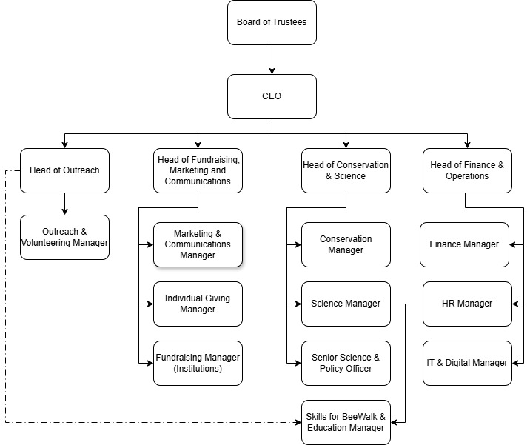

What being a Trustee involves
Our trustees play a vital role in making sure we achieve our core purpose. They oversee the overall management and administration of the charity. They also ensure that the Trust has a clear strategy and that our work and goals are in line with our vision. They support and challenge the executive team to enable the Trust to grow and thrive, and through this, increase the number and distribution of bumblebees.

The trustee role is as set out by the Charity Commission in its guidance on what is required of a charity trustee which can be found at: https://www.gov.uk/government/publications/the-essential-trustee-what-you-need-to-know-cc3 and we use the Charity Governance Code published in 2025 as a practical tool to support good governance of the Trust.

Trustees are co-opted onto the Board and seek election by the members at the following AGM. Following election, Trustees serve on the Board for three years. A maximum of two terms can be served. Individual trustees are accountable to the Board of Trustees. Board members have a collective responsibility. This means that trustees always act as a group and not as individuals. Board roles are not remunerated but the Trust will reimburse reasonable expenses for travel and accommodation incurred on approved Board duties

Board Meetings: There are four Board meetings each year and current practice is for three of these meetings to be half-day meetings held via videoconference, with a fourth full day meeting held in person at a mutually convenient location.
As well as regular business, time is dedicated to the development of the Board with training and strategy sessions. The work of the Board will be delivered via a combination of remote working and videoconferencing and in-person meetings where practical. Meetings often take place within standard working hours, with the calendar of meeting dates set annually to reflect the best fit for the Board members.

Committees: The Board has four committees. Trustees join these committees based on their interest and expertise, and it is anticipated that this appointee will attend the Finance Committee who take oversight of digital matters at Committee level. Committees normally meet for one to two hours in advance of each Board meeting and members attend these committees via videoconference.

There is one AGM a year which will be delivered online in 2026 on the evening of Wednesday 4th November.

The time commitment equates to around a day a month factoring in quarterly Board and Committee meetings, strategy work, training, preparation time and attending the AGM.

Trustees must declare that they are not disqualified from acting as a Trustee under the Charity Commission automatic disqualification rules and must declare any conflict of interests which may impact on their work for the Trust.

Recruitment Timeline

April / May 2026 | Advertisement of Role and shortlisting
June 2026 | Interviews, offer and appointment
June 2026 | Induction by CEO and Chair
June 2026 | Co-option at Board meeting on 24/25th June
November 2026 | Membership make appointment at the AGM in November 2026

How to Apply

Your application should be made to the Chair of the Board, Angela Style and submitted via email to Sarah Burrows. The closing date for submitting your application is 10am on Thursday 21st May.

If you wish, the Chair would be happy to have an informal conversation with you about the Trust and its strategy and approach to governance. Please contact Sarah Burrows to arrange this.

Submit the paperwork for application as follows:

- A covering letter, outlining your reasons for wishing to join the Board, what you could contribute, and what you would hope to achieve as a Board member.
- A brief CV, which should include the names and contact details of two people who could vouch for your abilities to serve on a Board and whom the Trust can contact, if necessary.
- A brief biography (maximum 150 words) which could be circulated to Trustees

We would also appreciate it if you would take the time to complete the anonymous Equality and Diversity Monitoring form here. The information you give us will help us to refine our recruitment and employment practices and respond to the needs of the diverse range of people that our organisation comes into contact with. All details that you provide will be kept in strict confidence and will not be viewed by any member of the selection panel.

The Bumblebee Conservation Trust is an Equal Opportunities employer. This means that when carrying out our work and in the employment of staff to undertake this work, we will seek to ensure accessibility and equity of treatment for all persons regardless of ethnicity, gender, age, marital status, disability, religion, sexual orientation, or economic status.

