

Recruitment Pack

Trustee & Finance Committee Chair
Contents

Join us to create a world where bumblebees are thriving and valued by everyone 3
Trustee & Finance Committee Chair Role Description 4
About Bumblebees 6
Governance 7
Organisational overview 7
Management Structure 7
Recruitment Timeline 9
How to Apply 9

Join us to create a world where bumblebees are thriving and valued by everyone
Thank you for your interest in the role of Trustee & Finance Committee Chair. This pack outlines who we are and who we are seeking to join our leadership team. This is your chance to be part of an organisation that is working with passionate people to deliver a positive impact on the environment.
Trustees work together, and with the executive team, with a spirit of openness and trust. We recruit individuals skilled in their field to fulfil the Board’s governance role, who are also passionate about nature, species conservation and bumblebees!
We’re very proud of our inclusive culture at the Trust – we care as much about what you have the potential to do, as what you have already done. We therefore welcome applications from those who are new to trusteeship, as well as those with previous experience. We value different perspectives to give us a better representation at Board level of the diverse audiences we seek to inspire to take action for bumblebees.
The Bumblebee Conservation Trust is a science-led organisation established in 2006 because of serious concerns about the ‘plight of the bumblebee’. In the last 80 years, our bumblebee populations have crashed. Two species have become nationally extinct, and several others have declined dramatically.
We have a vision to create a world where bumblebees are thriving and valued by everyone. Bumblebees are in crisis, and we are leading the fight to secure their future. Guided by the latest science we carry out research, influence environmental policy and conserve and create bumblebee friendly habitats. We inspire people and organisations to take action for our precious bumblebees, working together to help them thrive.
Our current ten-year strategy launched in April 2024 sets out five main aims to focus our work:
- We are the UK’s trusted experts on bumblebee populations, ecology and conservation.
- People and organisations, including policy makers, are inspired to champion and take action for bumblebees.
- There is more, better-connected, high-quality habitat for bumblebees across our cities, towns and countryside.
- Our threatened bumblebees are on the road to recovery, and no other bumblebees become threatened.
- We are an impactful, inclusive, bold and sustainable organisation.
We currently employ ca.50 staff, in full and part time roles, with an annual turnover of ca. £2m. The work of the Trust is supported by over 7,000 members. You can read more about our strategy and work at www.bumblebeeconservation.org
If you feel you could contribute your skills and experience to the strategic leadership of the Trust, then we would very much like to hear from you.
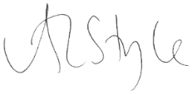
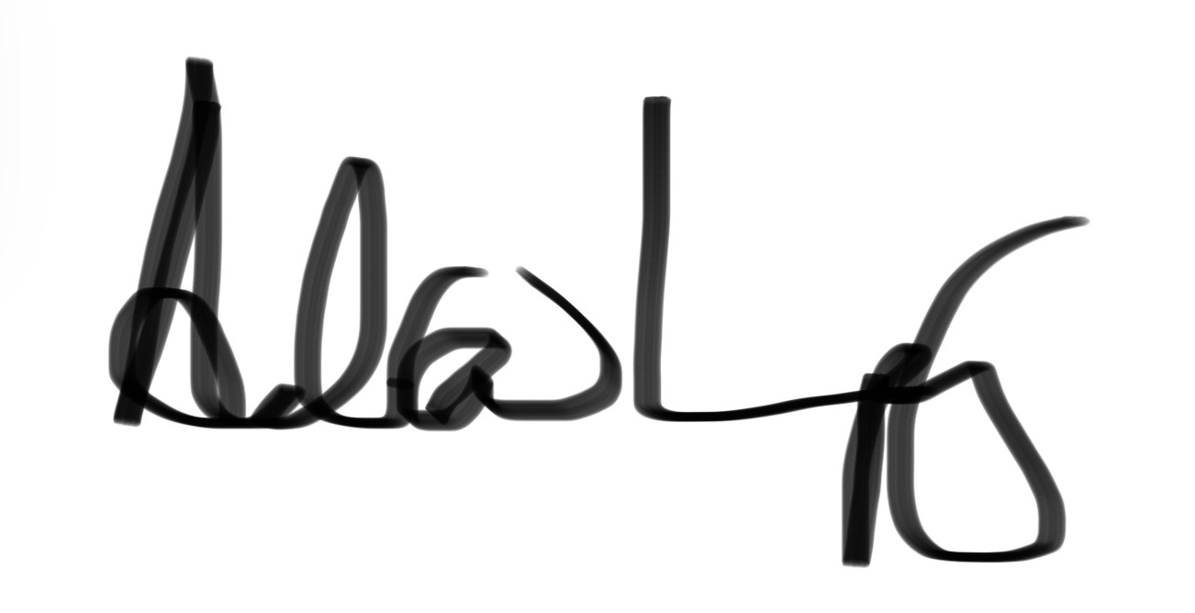

Angela Style Dr Andrew Impey
Chair of the Board of Trustees Chief Executive

Trustee & Finance Committee Chair Role Description

Background: A background in finance and accounting with an understanding of charity sector finance.

Role Summary:
This role is one of two Trustee positions on the Board providing oversight of the Trust’s finances and financial management. In addition to the general duties of trustees (more information here), the role involves:
- Monitoring the financial standing of the charity.
- Ensuring that the charity’s finances are managed responsibly.
- Overseeing the charity’s financial risk-management process.
- Chairing the Trust’s Finance Committee
- Overseeing reporting on financial matters to the Board of Trustees via quarterly Board meetings
- Providing general support and oversight for the effective running of the Trust as a member of the Board of Trustees.

Specific Finance Responsibilities – in conjunction with the Finance Trustee
Scrutiny of papers produced by the Head of Finance & Operations (HoFO) and the wider Senior Leadership Team in the following areas:

Budgeting and strategic financial planning
- Ensure that strategic plans are financially appraised and that implementation plans are aligned with budgets.
- Provide constructive challenge to the annual and longer-term budget and forecasting processes.
- Ensure transparency and accountability in resource allocation.
Management Reporting
- Ensure that a high standard of management accounting is maintained.
- Liaise with the HoFO and the Finance Committee in the preparation and production of high quality management accounts to the Board quarterly.
Statutory Financial Reporting
- Ensure the finalisation of statutory financial accounts by the HoFO, in line with charity regulations and statements of recommended practice, and the completion of the external audit process. Assist fellow trustees to formally approve the Trustees’ Annual Report and Annual Accounts
Reserves Policy
- Lead on the annual review of the reserves policy.
Keep the Board informed regularly of the free reserves position and advise on strategies for coping with changing circumstances.
Governance and Financial Control
- Ensure that proper accounting records are kept, financial resources are controlled, invested and economically spent in line with governance, legal and regulatory requirements.
- Attend and chair quarterly Finance Committee meetings and any occasional ad hoc meetings required and ensure the reporting of financial matters to the Board of Trustees.

Competencies

Essential
- Qualified Accountant with in-depth knowledge and experience of financial accounting and management.
- Ability to communicate and explain financial information to members of the Board and other stakeholders.
- Analytical and evaluation skills, demonstrating good judgement.
- Understanding and acceptance of the legal duties, responsibilities and liabilities of trusteeship.
- Good communication & leadership skills, including those necessary to run effective finance committee meetings as Chair (prior Chair experience not essential).
- Commitment to equality, equity, diversity and inclusion.

Desirable
- Knowledge and experience of charity finance; charity regulation; and/or charity fundraising practices.
- Dedication to the organisation’s cause and objectives and willingness to act as the charity’s ambassador to external bodies, charities and companies.
- Skills and experience in other areas of non-executive governance and management, e.g., strategic planning, business management, HR, legal, audit, risk management.
- Previous experience of Chairing Committees or Meetings.

Commitment
- Board roles are not remunerated though travel expenses can be paid
- An initial three-year term, that may be extended for one further three-year period
- Time commitment equates to around a day a month, with time required during office hours, for quarterly Board and Committee meetings (including prep), the AGM, strategy work and training

The work of the Board, will be delivered via a combination of remote working, video-conferencing and an annual in-person meeting in the UK (venue TBC based on attendees’ locations.)

Recruitment and selection for this role will be conducted on the basis of merit, against objective criteria that avoid discrimination. Our recruitment procedures are reviewed regularly to ensure that applicants are treated fairly on the basis of their relevant skills and abilities.

About Bumblebees
As a society we are increasingly dependent on pollinators. The proportion of global agricultural production that depends on pollinators has increased four-fold since 1961. Much of this dependence is linked to wild pollinators. Where data exist, we are seeing evidence of wild pollinator decline. Over 16 per cent of invertebrate pollinators are threatened with global extinction, 9 per cent of wild bee and butterfly species face local extinction and available National Red Lists show up to 50 per cent of bee species assessed are nationally threatened.
Pollinators provide a crucial service to nature and humans. Pollination directly affects the yield and/or quality of 75 per cent of globally important crops. The annual contribution of pollinators to the global economy is estimated at US$ 235–577 billion (Potts et al 2016).
It is well-known that bumblebees are extremely important pollinators, and they have a key role in producing much of the food that we eat. Through the pollination of many commercial crops such as tomatoes, peas, apples and strawberries, insects are estimated to contribute over £600 million per annum to the UK economy (2015), and in doing so prop up the £108 billion per-year food and drink industry in Britain. Across the EU, insect pollinators are estimated to contribute €14.2 billion annually to the EU economy (2012). If bumblebee and other insect pollinator declines continue, the extremely high cost of pollinating these plants by other means could significantly increase the cost of fruit and vegetables (hand-pollinating British crops has been estimated to cost £1.8 billion annually).
The story of bumblebees over the past century has been one of decline. Two species became extinct in the UK during the 20th century: Cullum’s bumblebee (Bombus cullumanus) last seen on the Berkshire Downs in 1941, and the Short-haired bumblebee (Bombus subterraneus), last seen at Dungeness in 1988 and officially declared extinct in 2000. A further eight species (a third of the remaining species) are currently listed on at least one of the English, Welsh and Scottish conservation priority species lists due to their large-scale declines in distribution.
By pollinating both crops and wildflowers, bumblebees are not only crucial for our food security, but also for maintaining biodiversity and ecosystem health. This important role is recognised by much of the general public, reflected in the positive image of bumblebees in British culture.
The Trust aims to harness this to protect bumblebee populations and diversity, thereby contributing to maintaining biodiversity and healthy habitats throughout urban and rural UK.

Governance
The Trust is governed by the Board of Trustees which is responsible for:
- Establishing the overall direction of the Trust, including its mission, aims and strategies.
- Ensuring that the policies of the Trust are in keeping with its aims and strategies.
- Working to ensure that the Trust has the resources, both human and financial, to achieve its aims and strategies.
- Monitoring and evaluating the progress of the Trust against its aims and targets.
- Ensuring that the Trust functions within legal and regulatory requirements.

Organisational overview
The Trust is a registered charity in England & Wales and in Scotland and has to meet the regulatory requirements of the Charity Commission and OSCR. The Trust has been set up as a charitable company limited by guarantee and, as such, Trustees are also directors of the charitable company.

Management Structure
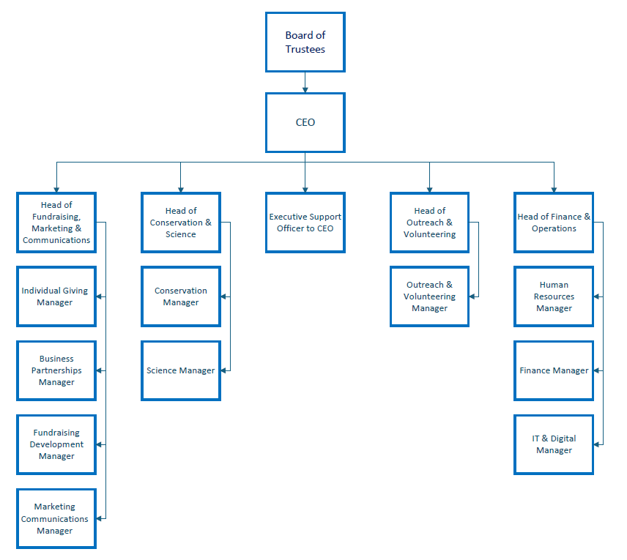

What being a Trustee involves
Trustees help ensure we achieve our core purpose by overseeing the charity’s management and administration, setting a clear strategy, and ensuring our work aligns with our vision. They support and challenge the Executive so the Trust can grow, thrive, and increase the number and distribution of bumblebees.

The trustee role is as set out by the Charity Commission in its guidance on what is required of a charity trustee which can be found at: https://www.gov.uk/government/publications/the-essential-trustee-what-you-need-to-know-cc3 and we use the Charity Governance Code published in 2025 as a practical tool to support good governance of the Trust.

Trustees are co-opted onto the Board and seek election by the members at the following AGM. Following election, trustees serve on the Board for three years. A maximum of two terms can be served. Individual trustees are accountable to the Board of Trustees. Board members have a collective responsibility. This means that trustees always act as a group and not as individuals. Board roles are not remunerated but the Trust will reimburse reasonable expenses for travel and accommodation incurred on approved Board duties

Board Meetings: There are four Board meetings each year, current practice is for three of these meetings to be half-day meetings held via videoconference, with a fourth full day meeting held in person in the UK at a mutually convenient location.
As well as regular business, time is dedicated to Board development with training and strategy sessions. Meetings often take place within standard working hours, with the calendar of meeting dates set annually to reflect the best fit for the Board members.

Committees: The Board has four committees. Trustees join these committees based on their interest and expertise, and this appointee would chair the Finance Committee. Committees normally meet for one to two hours in advance of each Board meeting and members attend these committees via videoconference.

There is one AGM a year which will be delivered online in 2026 on the evening of Wednesday 4th November.

The time commitment equates to around a day a month factoring in quarterly Board and Committee meetings, strategy work, training, preparation time and attending the AGM. Some time will be needed during regular office hours.

Trustees must declare that they are not disqualified from acting as a Trustee under the Charity Commission automatic disqualification rules and must declare any conflict of interests which may impact on their work for the Trust.

Recruitment Timeline

September/October 2026 | Advertisement of Role and shortlisting
November 2026 | Interviews, offer and appointment  Induction process commences
December 2026 | Co-option at Board meeting on 9th December
November 2027 | Membership make appointment at the AGM in November 2027*
*Voting takes place by proxy in advance of AGM so official appointment will be at AGM In 2027

How to Apply

Your application should be made to the Chair of the Board, Angela Style and submitted via email to Sarah Burrows.

If you wish, the Chair or the current Chair of Finance Committee would be happy to have an informal conversation with you about the Trust, its strategy and approach to governance or this role in particular. Please contact Sarah Burrows to arrange this.

Submit the paperwork for application as follows:

- A covering letter, outlining your reasons for wishing to join the Board, what you could contribute, and what you would hope to achieve as a Board member.
- A brief CV, which should include the names and contact details of two people who could vouch for your abilities to serve on a Board and whom the Trust can contact, if you are offered the role.
- A brief biography (maximum 150 words) which could be circulated to Trustees and staff

We would also appreciate it if you would take the time to complete the anonymous Equality and Diversity Monitoring form here. The information you give us will help us to refine our recruitment and employment practices and respond to the needs of the diverse range of people that our organisation comes into contact with. All details that you provide will be kept in strict confidence and will not be viewed by any member of the selection panel.

The Bumblebee Conservation Trust is an Equal Opportunities employer. This means that when carrying out our work and in the employment of staff to undertake this work, we will seek to ensure accessibility and equity of treatment for all persons regardless of ethnicity, gender, age, marital status, disability, religion, sexual orientation, or economic status.

